Unit 1 Practice

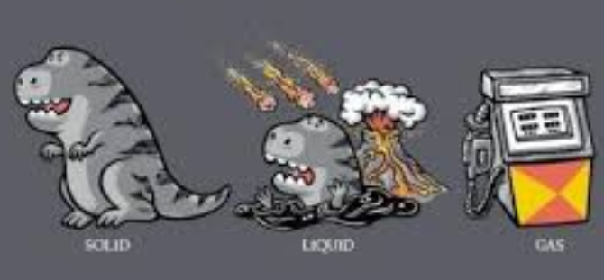

Problem Set #1-1 Name:____________________________

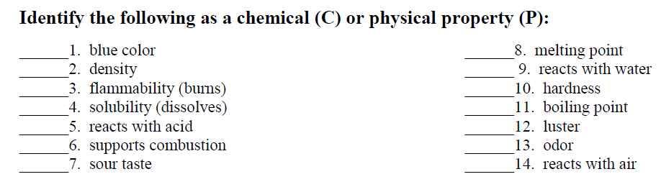
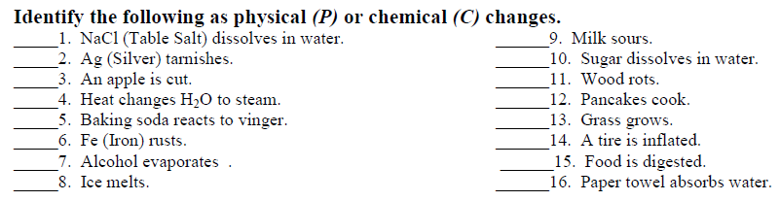

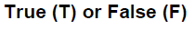
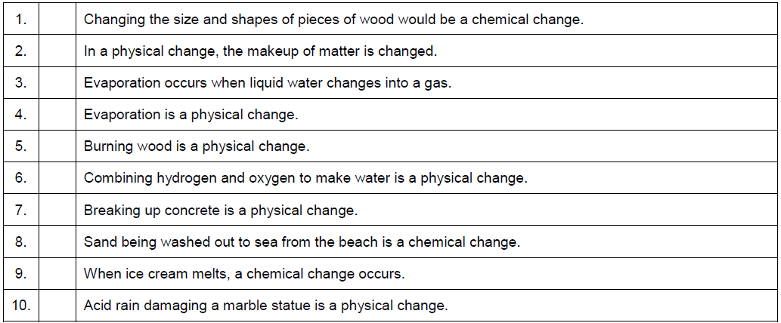
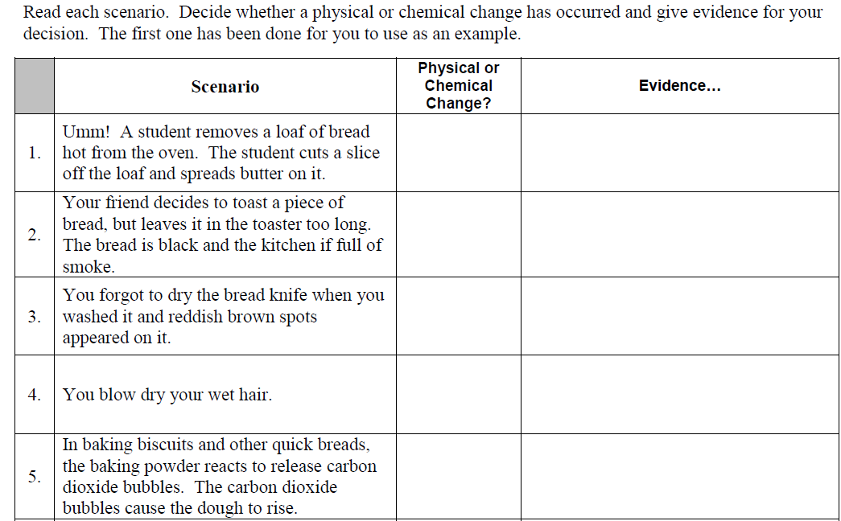
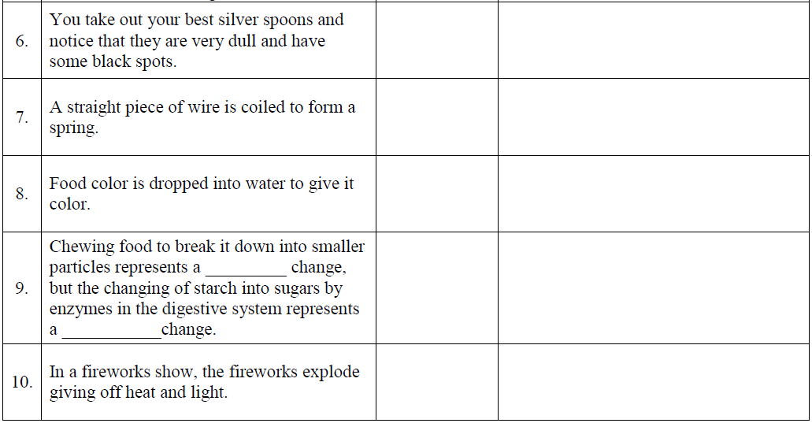
Problem Set #2
Use the following terms to describe the substance(s) inside each lettered box.
- Pure Substance or Mixture of Pure Substances
- If pure substance, element or compound.
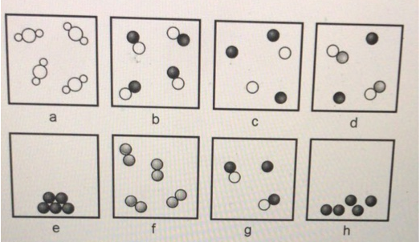
- Solid, liquid, gas or mixture of which states
a.
b.
c.
d.
e.
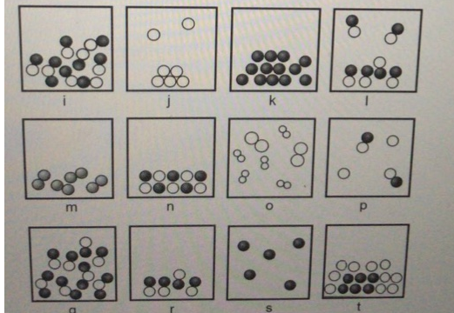
f.
g.
h.
i.
j.
k.
l.
m.
n.
o.
p.
q.
r.
s.
t.
Problem Set #3 Measurement
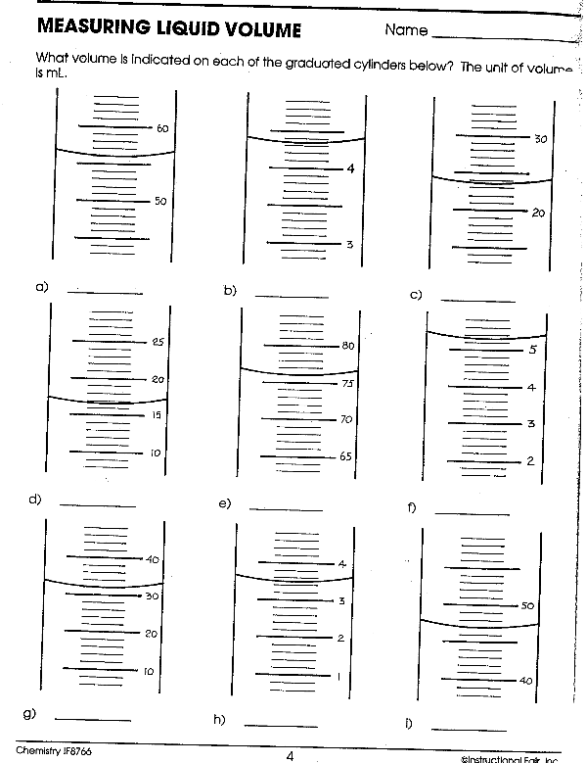
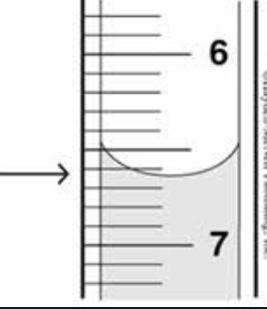
Problem Set #4 Scientific Notation and Significant Figures.
1. Write each of the following numbers in scientific notation:

a) 91,100 __________ b) 0.000000075 __________
c) 6400 __________ d) 0.00165 __________
2. Convert each of the following numbers in scientific notation to conventional decimal form:

a) 2.24 x 10⁻⁵______________ d) 2.95 x 10⁻³ ______________
b) 9.3 x 10² ______________ e) 7.35 x 10⁻² ______________
3. How many significant figures are in each of the quantities listed below:
a) 454 mg __________ d) 0.0680 km__________ g) 0.1536 g __________

b) 0.0353 L __________ e) 10.0 mL __________ h) 0.0060 g __________

c) 52.20 mL __________ f) 3 x 10⁷ kg __________ i) 1.898 x 10⁻³ g __________

j) 2500 m __________ k) 12 marbles

4. Round off the given quantity 7.758064 to the number of significant figures indicated:

one ____________________ three_____________________ five _____________________

two _____________________ four _____________________ six _____________________

5. Round off the quantity 0.00400559 to the number of significant figures indicated:

one _____________________ three_____________________ five _____________________

Homework #5: Density Problems

- Table salt has a density of 2.16 g/cm³. A cylindrical box holds 425 g of salt. What is the volume, in cm³, occupied by the salt in the box (ignore the spaces between the crystals)?

- A flask that masses 345.8 g is filled with 225 mL of carbon tetrachloride (a liquid solvent). The mass of the flask and the carbon tetrachloride is found to be 703.55 g. From this information, calculate the density of carbon tetrachloride in g/mL.

- A sample of iron shot with a mass of 28.3 g is added to a graduated cylinder containing 45.5 mL of water. The water rises to the 49.1 mL. Calculate the density of iron in g/cm³.

- Find the mass, in grams, of 0.250 L of benzene, a liquid solvent. The density of benzene is 0.90 g/mL.

- Ethyl alcohol is added to a beaker with mass 204.88 g until the beaker and alcohol together weigh 253.2 g. What volume, in liters, was added to the beaker? The density of ethyl alcohol is 0.789 g/mL.

- A student determines that the mass of a metal rod is 12.0 g. He places 10.0 mL of water in a graduated cylinder. When the metal rod is placed in the water, the graduated cylinder then reads 15.0 mL. What is the density of the metal rod?

- What is the density in g/cm³ of a rectangular piece of ivory that measures 0.23 m by 0.15 m by 0.155 m and has a mass of 10.222 kg? (Hint: change all of the meters to centimeters FIRST!)

- How many liters of water would be displaced by a rock with a density of 4.85 g/cm³ and a mass of 0.109 kg?

